Project Plan

Victorian Accident Analysis

Harris Huntington, Eric Martin

Table of Contents

1.0 Introduction 3

1.1 Background 3

1.2 Scope 3

1.3 Document contents 3

2.0 Work Breakdown Structure 4

3.0 Activity Definition & Estimation 5

4.0 Gantt Chart 6

# Introduction

## Background

A large dataset, the Victoria State Accident Dataset, has been presented to this team to be used in an analysis tool created to visualise and analyse parts of the data to be easily presented and understandable. This dataset contains road crash statistics from the five years between 2015 to 2020 within the Australian state of Victoria.

## Scope

This project is to create a python application which presents various data from Victoria State Accident Dataset in an easily understood visual manner that can be interacted with through a visual GUI. There are several predetermined analysis options that must be implemented allowing for the user to have a great deal of control over what data they wish to view and analyse. This project will only focus on those required features primarily. These documents will catalogue the planning and execution process of this project, including this project plan documenting the scheduling of the project, and the software design document detailing the specifics of the project.

## Document contents

This document contains a work breakdown structure (2.0) which is a breakdown flowchart of all the work required to complete the project. Section 3.0 is the activity definition in which each item from the work breakdown structure is explained in greater depth with reasonable time estimations. The final section of this document is the Gantt Chart (4.0), this section will take the items from the activity definition and present them in a Gantt chart format alongside the tracked time that the activities took to complete.

*Include some background information about the problem, the scope and what this document will contain.*

# Work Breakdown Structure

*This section should include the work breakdown structure for the whole project. The elements from the WBS should be used to generate your activity definition and those activities should then be scheduled in the Gantt Chart. Remember to consider ALL project activities – anything you do or will need to do should be included in the WBS*

*WBS’s are usually presented as some kind of hierarchical diagram/chart etc. The details what is involved each work unit should be provided in section 3:* ***Activity Definition***

*You do NOT need to do a WBS Dictionary for this project – the activity definition (whilst slightly different) will suffice. The WBS is focussed on SCOPE. The Activity definition is focussed on TIME.*

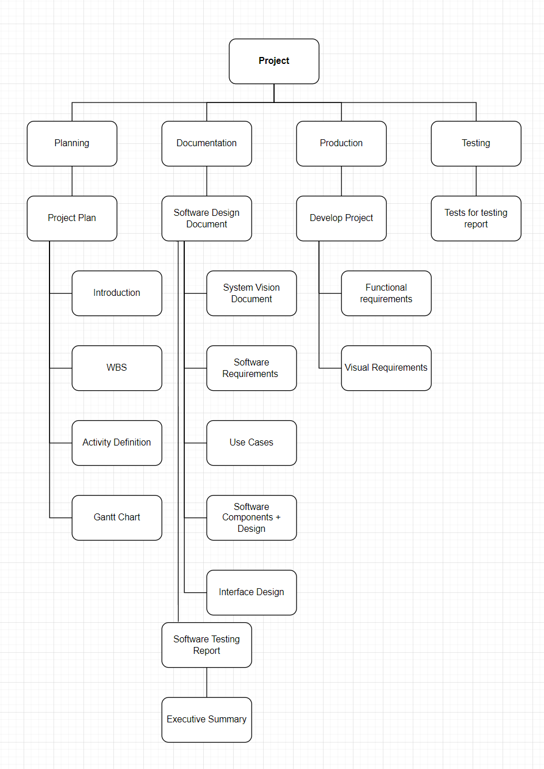

# Activity Definition & Estimation

*From your WBS, define the activities required for your project. You will revise this document and add more detail for part B as you discover more about the project.*

*Each activity should be clearly identified by a number and should match up to your Gantt chart. You should provide some estimations for the time you think each activity will take. This should make it easy to prepare your Gantt chart.*

## Planning

3 Days

Overall planning of the project

## Project Plan

3 Days

Project planning document, contains sections outlining the activities

## Introduction

0.5 Days

Overview of project

## WBS

1 Day

Breakdown of all activities involved for completing the project

## Activity Definition

1 Day

Definition and time duration of all activities described within the WBS

## Gantt Chart

0.5 Days

Tracked visual representation of all activities and durations described in the activity definition

## 2.0 Documentation

7 Days

Includes the software design document, software testing report, and executive summary.

## 2.1 Software Design Document

5 Days

## 2.1.1 System Vision Document

1 Day

Background of the dataset, overview of the software, potential benefits of the software

## 2.1.2 Software Requirements

1 Day

User requirements and software/function requirements

## 2.1.3 Use Cases

1 Day

Diagrammed blending of the user and software requirements, detailing how the user will interact with the product

## 2.1.4 Software Components and Design

1 Day

Flowchart, functions, class structures, algorithms. Listing of the main components

## 2.1.5 Interface Design

1 Day

Structural flowchart design and wireframes of the software interface

## 2.2 Software Testing Report

1 Day

Testing report of software, ensure all functions and criteria function as expected

## 2.3 Executive Summary

1 Day

Final summary of all documentation and project information

## 3.0 Production

15 Days

Developing the project

## Develop Project

15 Days

Development of the project

## 3.1.1 Functional Requirements

11 Days

Development of functional aspects of the product. Algorithms, functions etc

## 3.1.2 Visual Requirements

4 Days

Implementation of visual interface, following wireframes/flowchart

## 4.0 Testing

3 Days

Testing of the project

## 4.1 Tests for Testing Report

3 Days

Completing and recording tests as outlined in 2.2 Software Testing Report

# Gantt Chart

*This section should contain your Gantt chart. The items in the Gantt chart should match the activity definition from section 3. You should also submit your Gantt chart file separately.*

